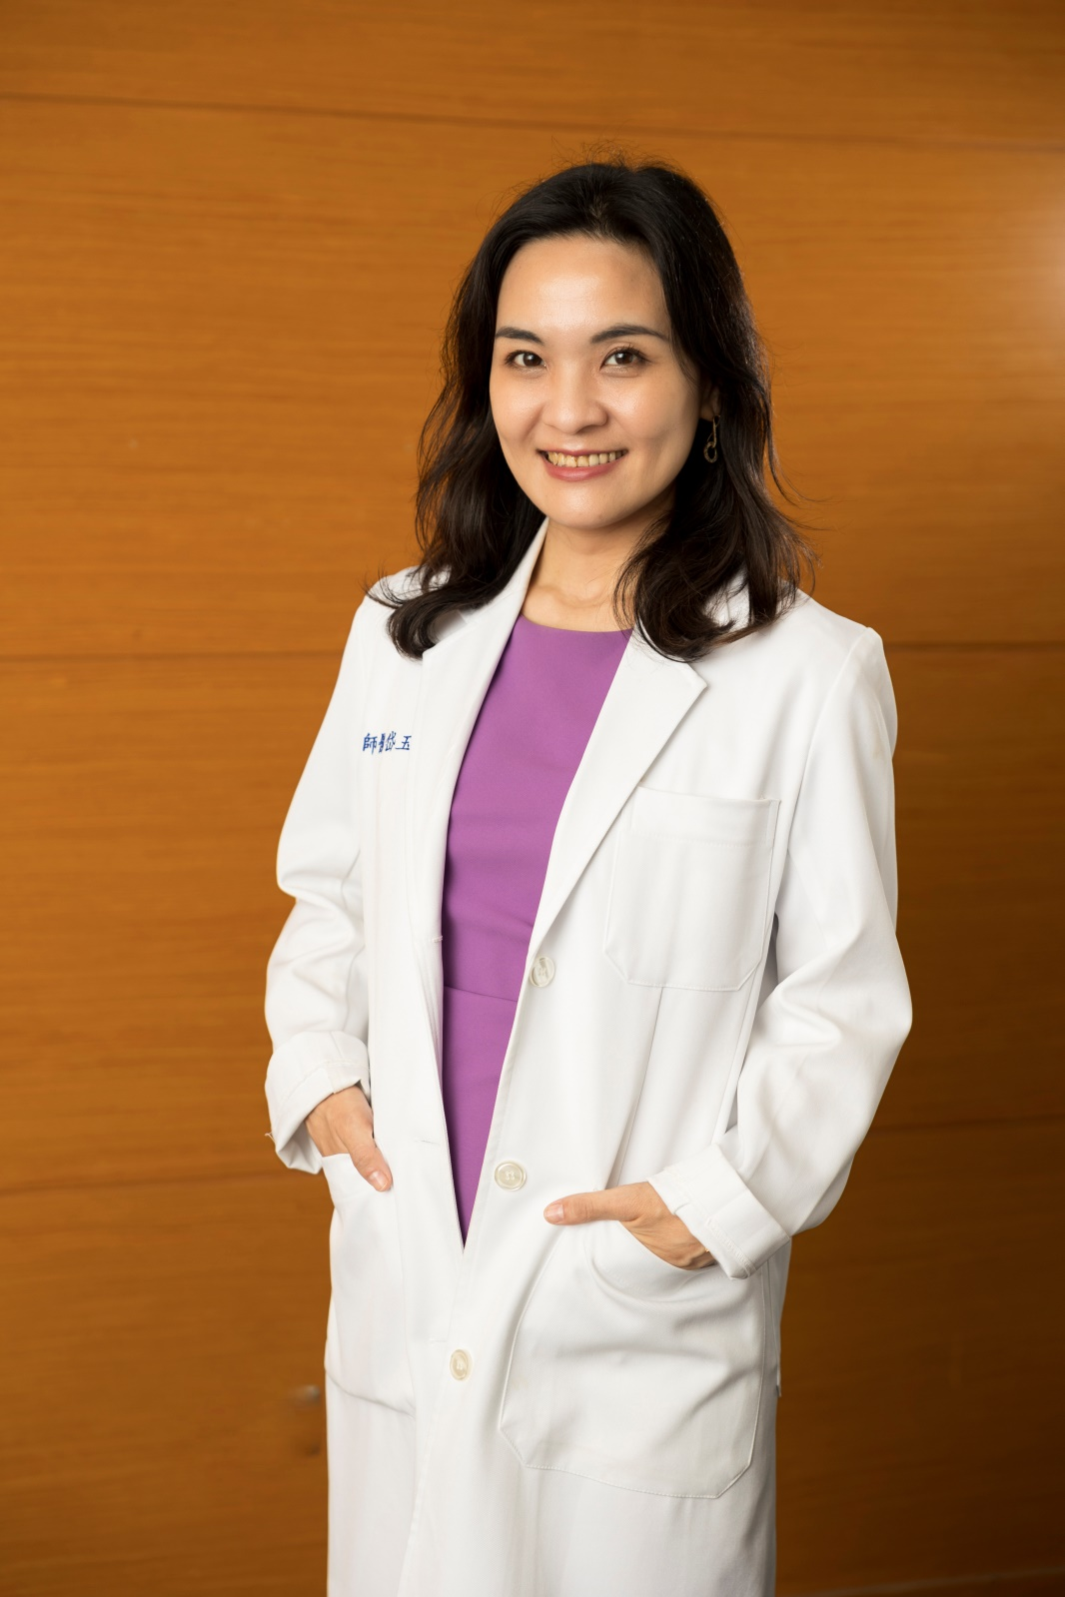 **Yu-Tai Lo, MD, MSc**

**Brief Biography**

Dr Yu-Tai Lo is a geriatrician at National Cheng Kung University Hospital (NCKUH) and currently serves as Assistant Professor at the Department of Geriatrics, College of Medicine, National Cheng Kung University (NCKU). She holds board certifications in Family Medicine, Geriatric Medicine, Palliative Medicine, and Hospitalist. She is currently pursuing a PhD in Public Health at NCKU.

With over two decades of clinical experience—spanning both community-based and tertiary hospital settings—Dr Lo has developed expertise in caring for older adults with multimorbidity, frailty, and end-of-life needs. She has played a leading role in establishing age-friendly outpatient services and developing integrated care models, including geriatric evaluation and interdisciplinary long-term care pathways.

Dr Lo is also deeply involved in medical education. She is the lead educator for fifth- and sixth-year medical student clerkships in geriatric medicine at NCKUH and contributes to various interdisciplinary training programs. She teaches core modules such as "Geriatric Ethics and Law" and “Palliative Care for Frail Older Adults” for postgraduate year (PGY) residents, and lectures in the Institute of Gerontology on topics like "Palliative Medicine" and "Creative Ageing for Dementia Care." She also teaches undergraduate general education courses at NCKU on ageing and dementia, medical ethics, and the impact of death on families. Notably, she developed the online MOOC course “Medication and Nutritional Self-Care for Older Adults” on the NCKU N3Learning platform, which won the 2022 Taiwan Open Education Excellence Award.

Her research focuses on integrated care for older adults, effectiveness of geriatric outpatient services, utilization of palliative care among older adults, incorporating home-based care settings into geriatric medical education, and advance care planning among older adults. She was the principal investigator of a cohort study on integrated outpatient care for older adults with multimorbidity, supported by the National Science and Technology Council. She has been actively involved in several large-scale, government-funded initiatives aimed at enhancing the quality and accessibility of care among older adults. These include national efforts to improve acute and long-term care for older adults, strengthen functional assessment services, and develop post-pandemic smart care models based on intrinsic capacity. She is also contributing to the integration of artificial intelligence into hospital-centered health systems that support daily life and precision care for the ageing population.

**Clinical and Research Focus**

* Care for older adults with multimorbidity and polypharmacy
* Utilization of palliative care among older adults
* Integrated care for older adults
* Advance care planning and end-of-life decision making
* Incorporating home visits in geriatric medicine training for postgraduate medical education
* Implementation of age-friendly health systems and services
* Health promotion and resilience among community-dwelling older adults
* Application of public health approaches in geriatric care

**Current Academic and Professional Appointments**

* Attending Physician, Department of Geriatric Medicine, National Cheng Kung University Hospital
* Head, Long-term Care Section, Community Health Care Centre, National Cheng Kung University Hospital
* Assistant Professor, Department of Geriatrics, College of Medicine, National Cheng Kung University
* PhD Candidate, Institute of Public Health, National Cheng Kung University
* Committee Member, Continuing Education and Interprofessional Development Committee, Taiwan Association of Family Medicine
* Executive Board Member of Formosan Association of Care and Education for the Seniors

**Previous Academic and Professional Appointments**

* Medical Director, Department of Community Health, St. Joseph Hospital, Kaohsiung
* Medical Director, Department of Family Medicine, Jiannren Hospital, Kaohsiung
* Honorary Consultant, Kaohsiung Music and Wellness Charity Association

**Publications (last 5 years)**

ORCID: <https://orcid.org/0000-0002-9363-8219>

1. **Lo YT,** Su HC, Chuenchomnoy C, Liao TW, Wu YL, Tam SH, Liu CH, Chou CW, Yang YC, Chen YH, Chen YC. Umbrella review of nonpharmacological interventions for intrinsic capacity in older adults. Ageing Res Rev. 2025 Apr 5;108:102742.
2. **Lo YT**, Fan SY, Li CY, Yang DC, Huang CC, Chen MH. Prevalence and factors associated with informal advance care planning discussion and do-not-resuscitate directives in patients at geriatric clinics. J Formos Med Assoc. 2025 Mar 28:S0929-6646(25)00142-1.
3. **Lo YT**, Chuang TJ, Huang YT, Wu YL, Yang YC, Li CY. Trends in palliative care utilization among older adult decedents with and without cancer in Taiwan: a population-based comparative study. Lancet Reg Health West Pac. 2025 Jan 28;55:101479.
4. **Lo YT**, Chen YJ, Wu JY, Lai CC. Effectiveness of advance care planning programmes in improving end-of-life outcomes for individuals with dementia and their caregivers in nursing homes: protocol for a systematic review and meta-analysis. BMJ Open. 2024 Dec 4;14(12):e088646.
5. Lee CB, Ku LE, Chou YT, Chen HY, Su HC, Wu **YT, Lo** YT, Yang YC, Li CY. Association of intrinsic capacity and medication non-adherence among older adults with non-communicable diseases in Taiwan. J Nutr Health Aging. 2024 Aug;28(8):100303.
6. Chia-Jung Hu, Ling-Hui Chang, **Yu-Tai Lo**, Jing-Jy Wang* (2024). Exploring healthcare providers’ difﬁculties and strategies when caring for community-dwelling people with dementia who are at risk of getting lost. Journal of Applied Gerontology. 43(12):1905-1913.
7. Chih-Wei Chang, Chih-Hsing Wu, Ru-Hsueh Wang, **Yu-Tai Lo**, Pao-Chi Liao* (2024). Establishing a biomonitoring baseline by characterizing the hair metabolome across age and sex using high-resolution mass spectrometry. Journal of Environmental Exposure Assessment. 3:19.
8. Chia-Ming Chang*, Chung-Ying Lin, Fang-Wen -Hu, Ying-Wei Wang, Chi-Chang Huang, **Yu-Tai Lo**, Chien-Yuan Wu, Yuan-Fang Chung, Chiu-Chen Kang, Yi-Jung Chen, Yi-Ching Yang, Li-Fan Liu, Mark D Griffiths, Dai-Chan Lin, Meng-Ru Shen* (2024). Clinimetric properties of the "FIND-NEEDS" to screen geriatric conditions. Gerontology. 70(9):893-902.
9. Yu-Sheng Hu, **Yu-Tai Lo**, Yi-Ching Yang*, Jiun-Ling Wang* (2024). Frailty in Older Adults with Dengue Fever. Medicina. 60(4):537.
10. **Yu-Tai Lo**, Jin-Jy Wang, Yi-Ching Yang, Chiu-Yen Yu, Chia-Ming Chang, Ya-Ping Yang* (2024). Effects of advance care planning on end-of-life indicators for nursing home residents—an experimental study with a retrospective chart review. Geriatrics. 9(2):42.
11. Chih-Wei Chang, Jen-Yi Hsu, **Yu-Tai Lo**, Yu-Hsuan Liu, Onanong Mee-inta, Hsueh-Te Lee, Yu-Min Kuo*, and Pao-Chi Liao* (2024). Characterization of Hair Metabolome in 5xFAD Mice and Patients with Alzheimer’s Disease Using Mass Spectrometry-Based Metabolomics. ACS Chemical Neuroscience. 15(3), 527−538
12. **Yu-Tai Lo**, Mei-Hua Chen, Tsung-Hsueh Lu, Ya-Ping Yang, Chia-Ming Chang, Yi-Ching Yang* (2024). Effects of an integrated ambulatory care program on healthcare utilization and costs in older patients with multimorbidity: a propensity score-matched cohort study. BMC Geriatrics. 24(1):109.
13. **Yu-Tai Lo**, Mei-Hua Chen, Pin-Hao Chen, Feng-Hwa Lu, Chia-Ming Chang, Yi-Ching Yang* (2024). Effectiveness of an integrated ambulatory care program on healthcare and medication use in patients with multimorbidity and polypharmacy. Quality Management in Health Care. 33(1):18-28.
14. **Yu-Tai Lo**, Ying-Chen Chi, Chia-Ming Chang, Ichiro Kawachi, Tsung-Hsueh Lu* (2023). Changes in place of death trends among Asian American older adults with dementia in the United States from 2004 to 2021. Journal of the American Geriatrics Society. 71(11):3628-3631. Research Letter.
15. Pei-Chia Yen, **Yu-Tai Lo**\*, Chih-Cheng Lai, Ching-Chi Lee, Ching-Ju Fang, Chia-Ming Chang, Yi-Ching Yang (2023). Effectiveness of outpatient geriatric evaluation and management intervention on survival and nursing home admission: a systematic review and meta-analysis of randomized controlled trials. BMC Geriatrics. 23:414.
16. Shu-Yu Tai, Ying-Chen Chi, **Yu-Tai Lo**, Yu-Wen Chien, Ichiro Kwachi, Tsung-Hsueh Lu* (2023). Ranking of Alzheimer's disease and related dementia among the leading causes of death in the US varies depending on NCHS or WHO definitions. Alzheimer's & Dementia: Diagnosis, Assessment & Disease Monitoring. 15:12442. Short Repot.
17. **Yu-Tai Lo**, Mei-Ching Chang, Sheng-Yu Fan, Chia-Ming Chang. (2023). Integrated Care for Older People, ICOPE。The Journal of Long-Term Care. 26(1): 1-15.
18. Chih-Chieh Chou, **Yu-Tai Lo**\*, Hui-Chen Su, Chia-Ming Chang (2022). Fear of falling as a potential complication of Ramsay Hunt syndrome in older adults: a case report. BMC Geriatrics. 22:901.
19. Fang-Wen Hu, Cheng-Han Lin, Fang-Ru Yueh, **Yu-Tai Lo**, Chung-Ying Lin*. (2022). Development and Psychometric evaluation of the physical resilience instrument for older adults (PRIFOR). BMC Geriatrics. 22:229.
20. **Yu-Tai Lo**, Chia-Ming Chang, Feng-Hwa Lu (2022)。Skills for Discussing Advance Care Planning with Older Adults. Taiwan Geriatrics & Gerontology. 17(1): 1-13.
21. **Yu-Tai Lo**, Chia-Ming Chang, Mei-Hua Chen, Fang-Wen Hu, Feng-Hwa Lu (2021). Factors associated with early 14-day unplanned hospital readmission: A matched case–control study. BMC Health Services Research. 21: 870. **Yu-Tai Lo**, Jay Chie-hen Liao, Mei-Hua Chen, Chia-Ming Chang, Cheng-Te Li (2021). Predictive modeling for 14-day unplanned hospital readmission risk by using machine learning algorithms. BMC Medical Informatics and Decision Making. 21: 288.
22. **Yu-Tai Lo**, Feng-Hwa Lu, Yi-Ching Yang (2021). Promoting Well-Being in Old Age from Physical, Psychosocial and Spiritual Perspectives. Taiwan Journal of Family Medicine. 31(3): 157-168.

**Current and recent research projects:**

* + - 1. “Acute Care for the Elderly in Taiwan” program (2020–2022), supported by the Health Promotion Administration, Ministry of Health and Welfare (Co-PI).
      2. “Long-Term Care Quality Assessment Program” (2021) supported by the Department of Long-term Care, Ministry of Health and Welfare (Co-PI).
      3. “The Challenges of Super-aged Society—A Prospective Cohort Study Exploring Outcomes of the Integrated Ambulatory Care Programs among Seniors with Multi-morbidity” (2021), supported by National Science and Technology Council (PI).
      4. “Health care systems without walls in the post-pandemic era: The development and evaluation of intrinsic-capacity-based technology-facilitated models of integrated care for older people and their caregivers” (2022-2025), supported by the National Health Research Institute (Co-PI).
      5. “Development of an AI-Driven U-Health eco-System Hubbed on Hospitals: Seamless Integration of Smart Precision Health Care for Older People in their Daily Lives (U-Health: Ubiquitous Healthcare)” (2024-2026), supported by National Science and Technology Council (Co-researcher).
      6. “Evaluation of medication and healthcare utilization related outcomes in older multimorbidity patients under integrated ambulatory care program” (2025), supported by National Cheng Kung University Hospital (PI).

**Awards and Honors**

* 2025 Award for Dedication to Clinical Teaching, National Cheng Kung University Hospital
* 2024 Recipient of the Silver Award in the Poster Competition Category of the Taiwan Healthcare Quality Management Competition, hosted by the Taiwan College of Healthcare Executives
* 2023 Outstanding Poster Presentation Award (12th IAGG Asia/Oceania Regional Congress)
* 2022 Taiwan Open Education Excellence Award
* 2018 Best Presentation Award (APACPH collaborating centers for Health Promotion)

**Videos/News/etc**

* <https://www.youtube.com/watch?v=UeuN_2_psnY>
* <https://www.cw.com.tw/aging/article/5129135>
* <https://www.cw.com.tw/article/5125409>
* <https://www.cw.com.tw/article/5121580>
* <https://health.udn.com/health/story/6001/5793825>
* <https://health.udn.com/health/story/6001/5681804>
* <https://www.commonhealth.com.tw/article/76222>
* <https://www.commonhealth.com.tw/article/70775>